**Task 4-Graphs and charts**

**Primary Research -**

The statistical graph shows the numbers of users from my local area from different age groups who have attempted the survey for the year 2020.

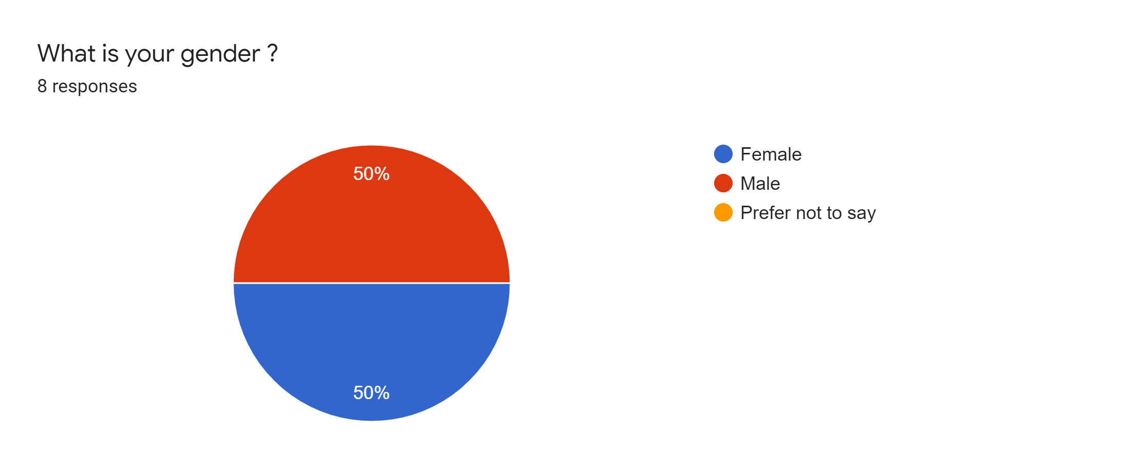

**Secondary research -**

The statistics below from the internet shows the number of users in different age groups and how many users have attempted the survey for the year 2020.

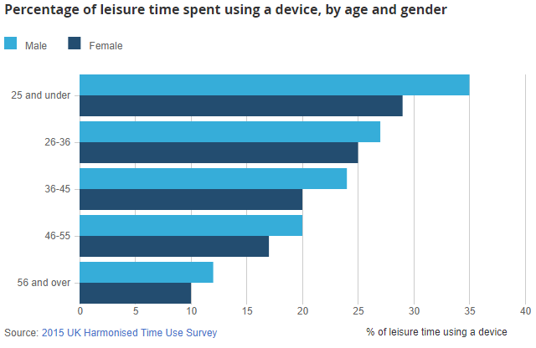

**Primary Research -**

The statistical graph shows the numbers of users from my local area from different age groups who have access to devices for the year 2020.

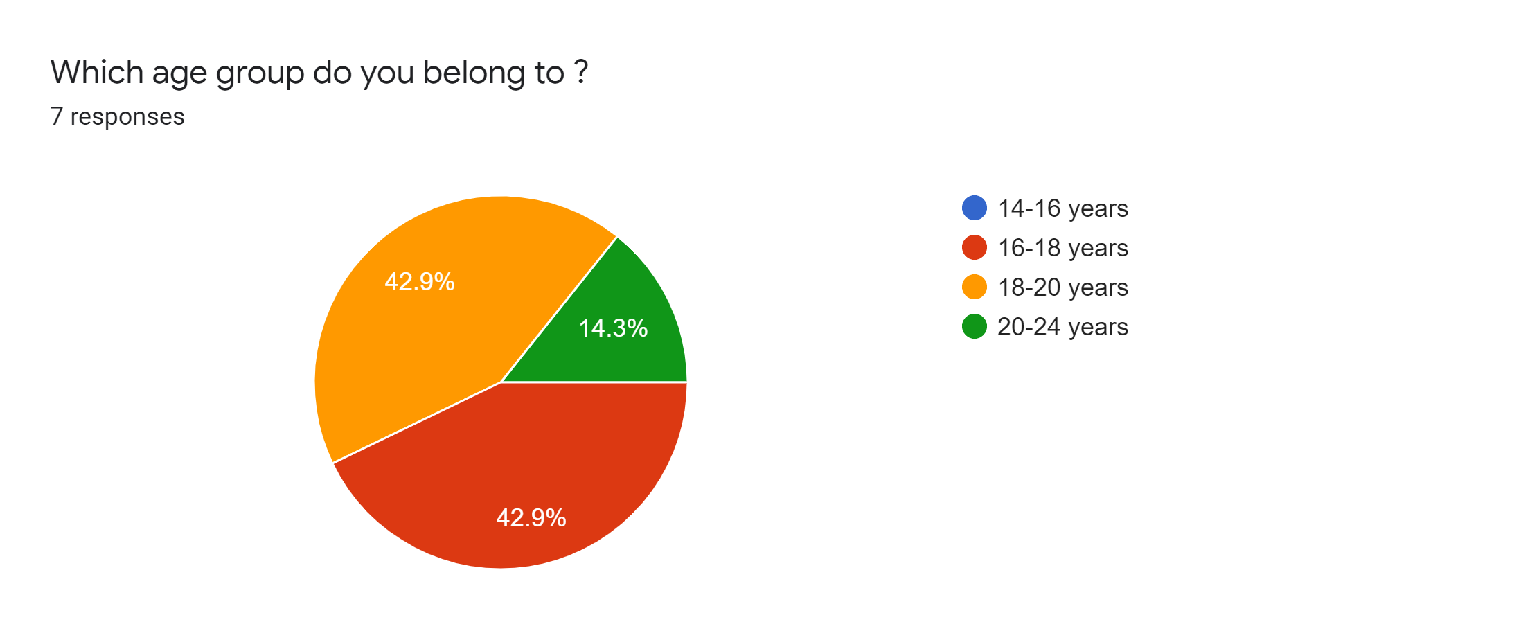

**Secondary research -**

The statistics below from the internet shows the number of users in different age groups and how many users have access to devices for the year 2019

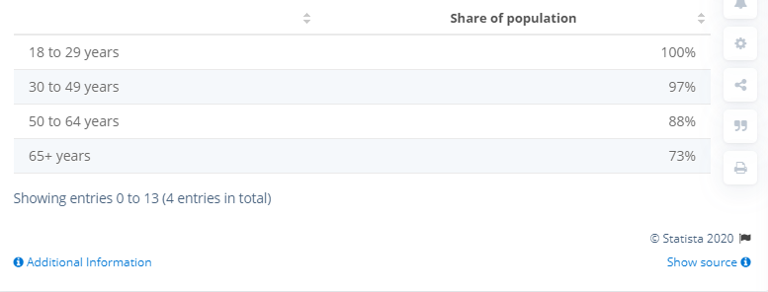

**Primary Research -**

The statistical graph shows the numbers of users from my local area from different age groups and how much time users have spent on their devices for the year 2020.

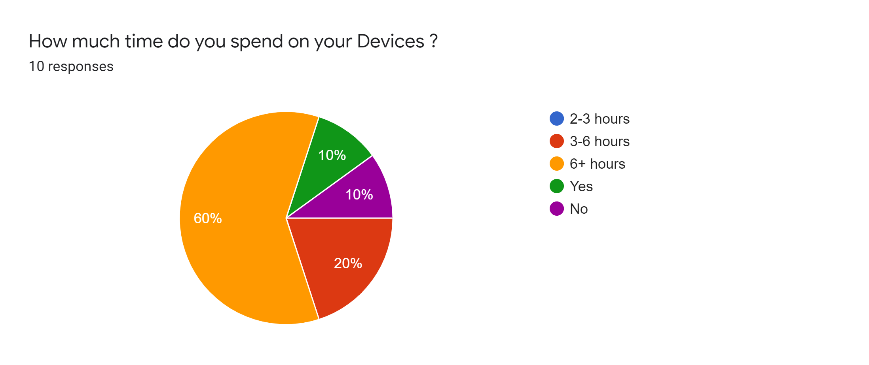

**Secondary research -**

The statistics below from the internet shows the number of users in different age groups and how much time users have spent on their devices for the year 2019

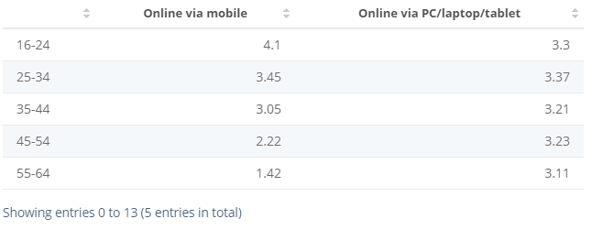

**Primary Research -**

The statistical graph shows the numbers of users from my local area from different age groups and how many devices users use for the year 2020.

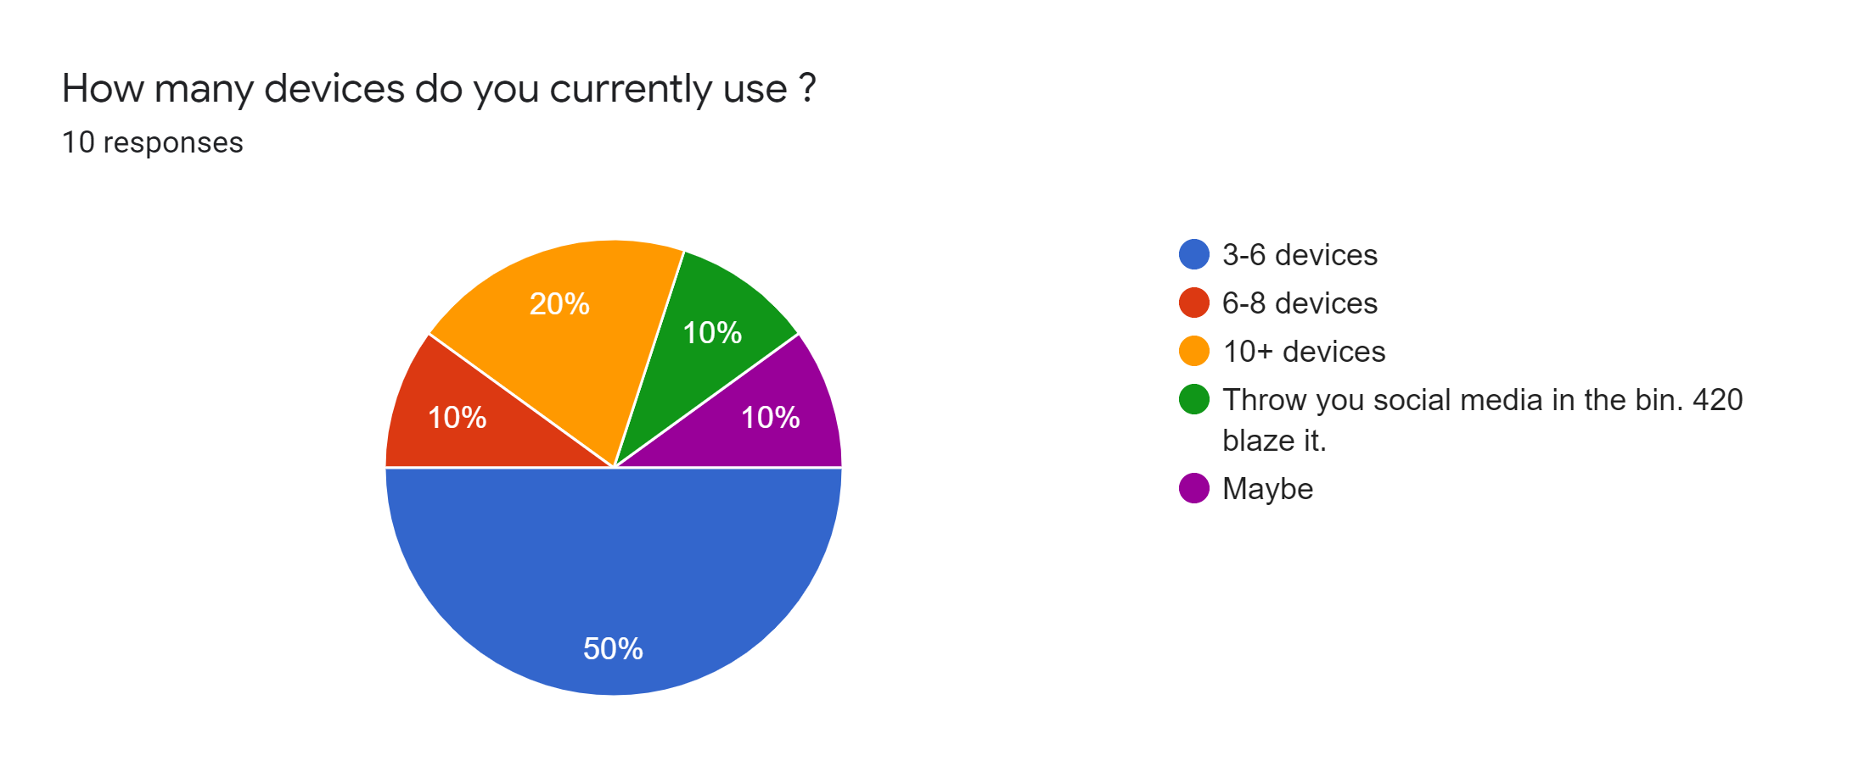

**Secondary research -**

The statistics below from the internet shows the number of users in different age groups and how much time users have spent on their devices for the year 2019

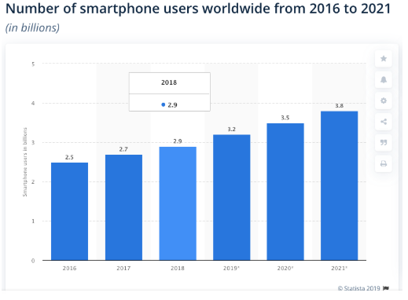

**Primary Research -**

The statistical graph shows the numbers of users from my local area from different age groups and how devices affect user’s daily tasks for the year 2020.

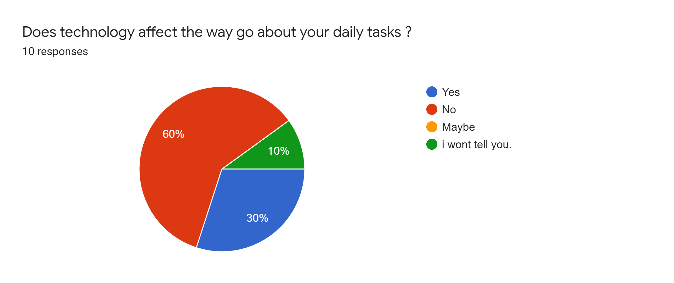

**Secondary research -**

The statistics below from the internet show the number of users in different age groups and how devices affect user’s daily tasks for the year 2020.

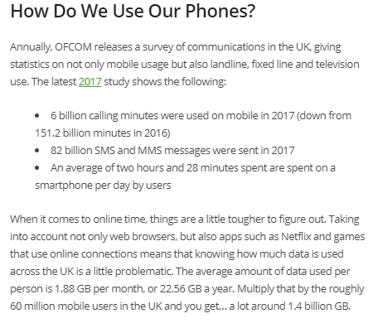

**Primary Research -**

The statistical graph shows the numbers of users from my local area about if user’s would like to share their private information publicly for the year 2020.

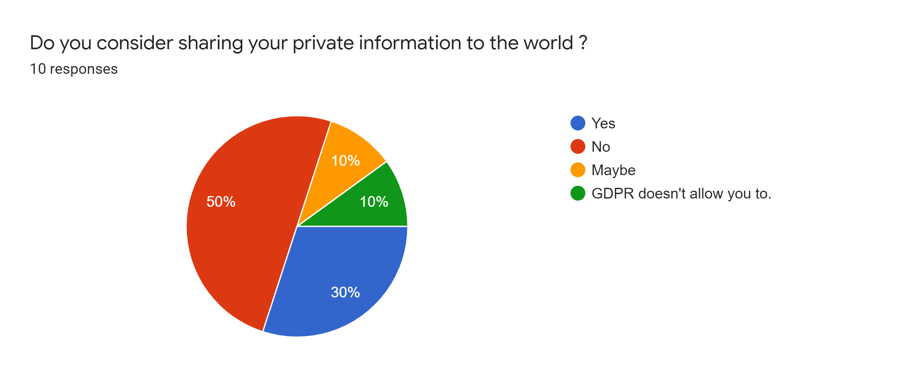

**Secondary research -**

The statistics below from the internet show the number of users in different age groups about if user’s would like to share their private information publicly for the year 2020.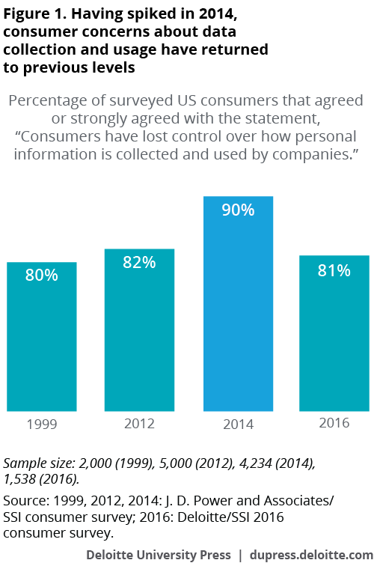

**Primary Research -**

The statistical graph shows the numbers of users from my local area about if users trust social media companies with their personal information for the year 2020.

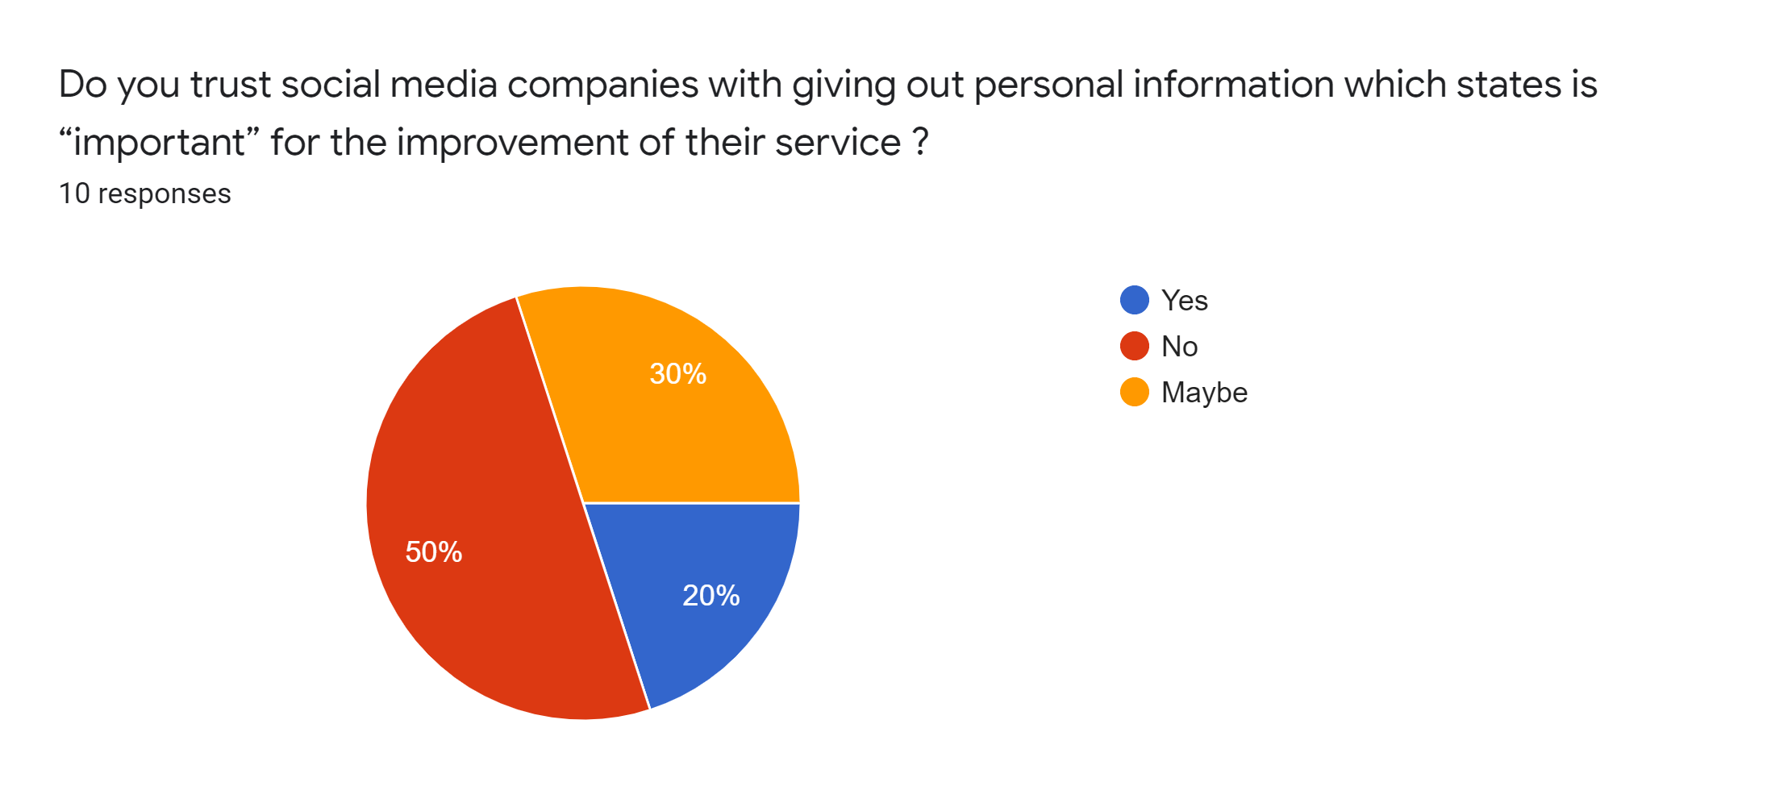

**Secondary research -**

The statistics below from the internet show the number of users in different age groups about if users trust social media companies with their personal information for the year 2020.

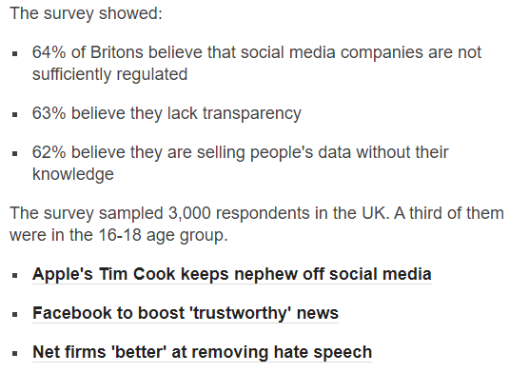

**Primary Research -**

The statistical graph shows the numbers of users from my local area about if users trust social media applications with their personal information for the year 2020.

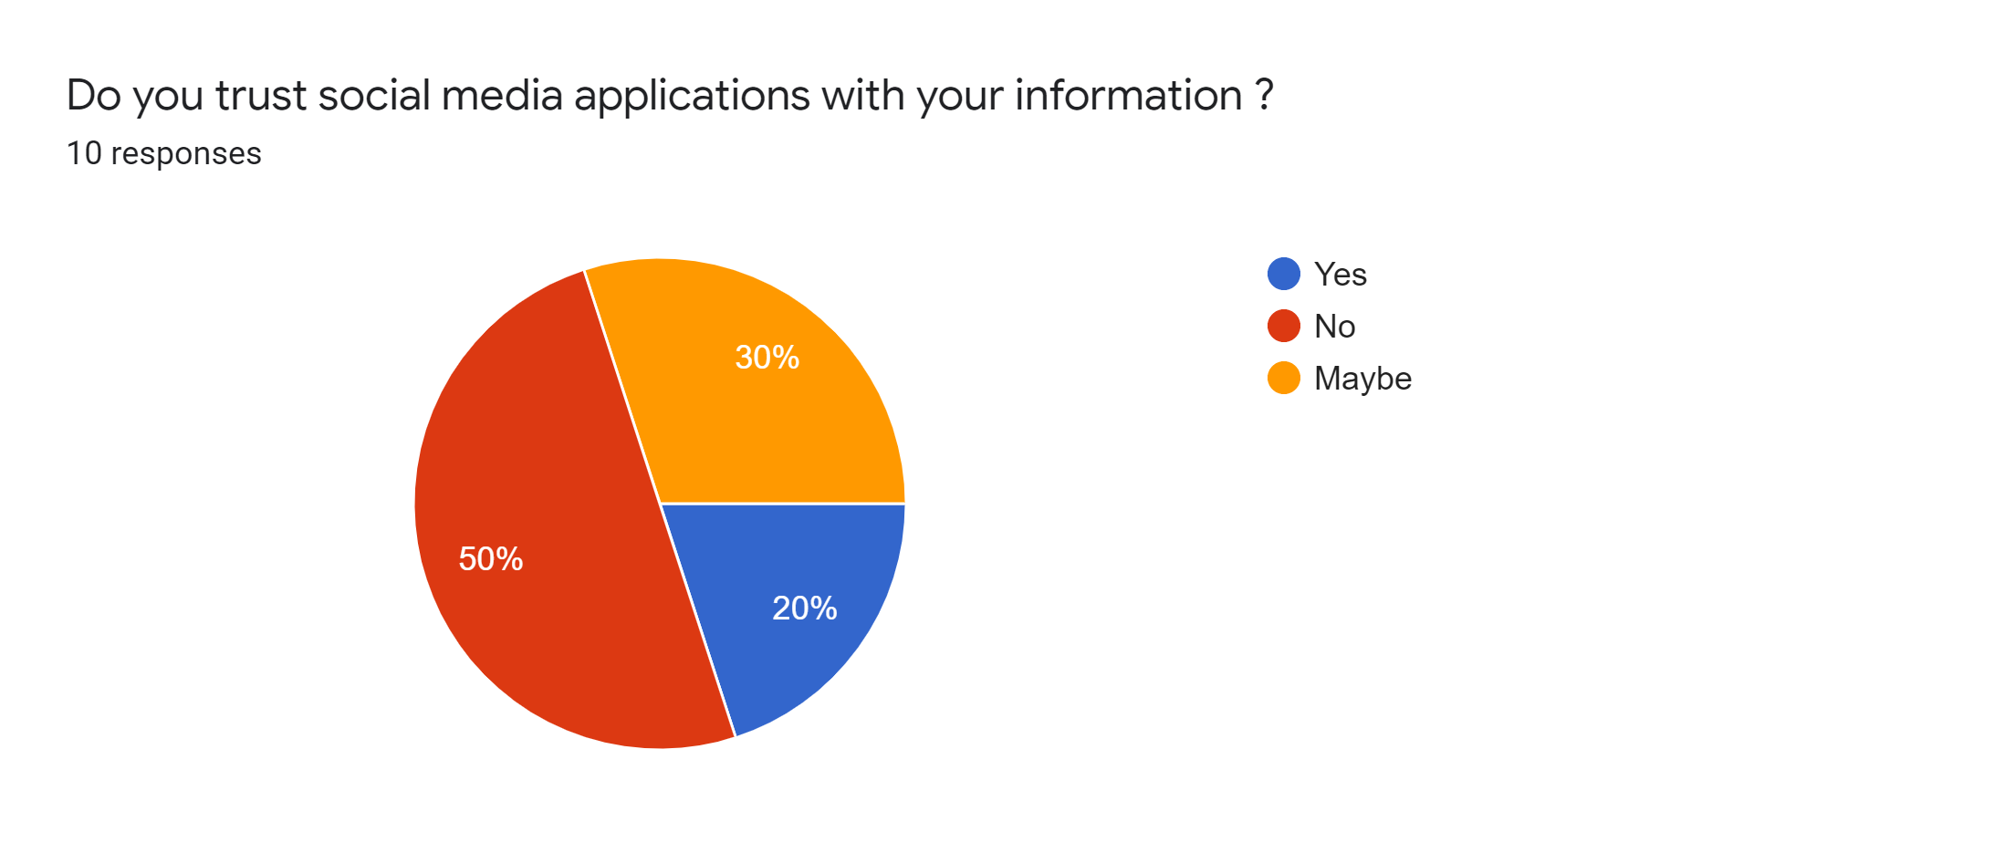

**Secondary research -**

The statistics below from the internet show the number of users in different age groups about if users trust social media applications with their personal information for the year 2020.

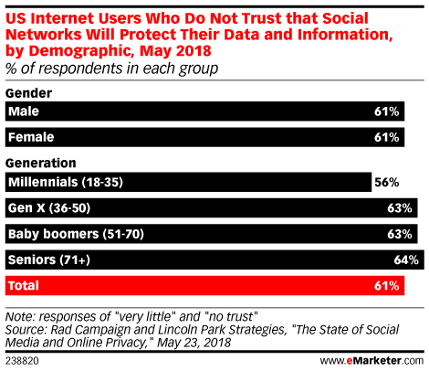

**Primary Research -**

The statistical graph shows the numbers of users from my local area about if users trust social media companies with their personal information and not use it against them in any way for the year 2020.

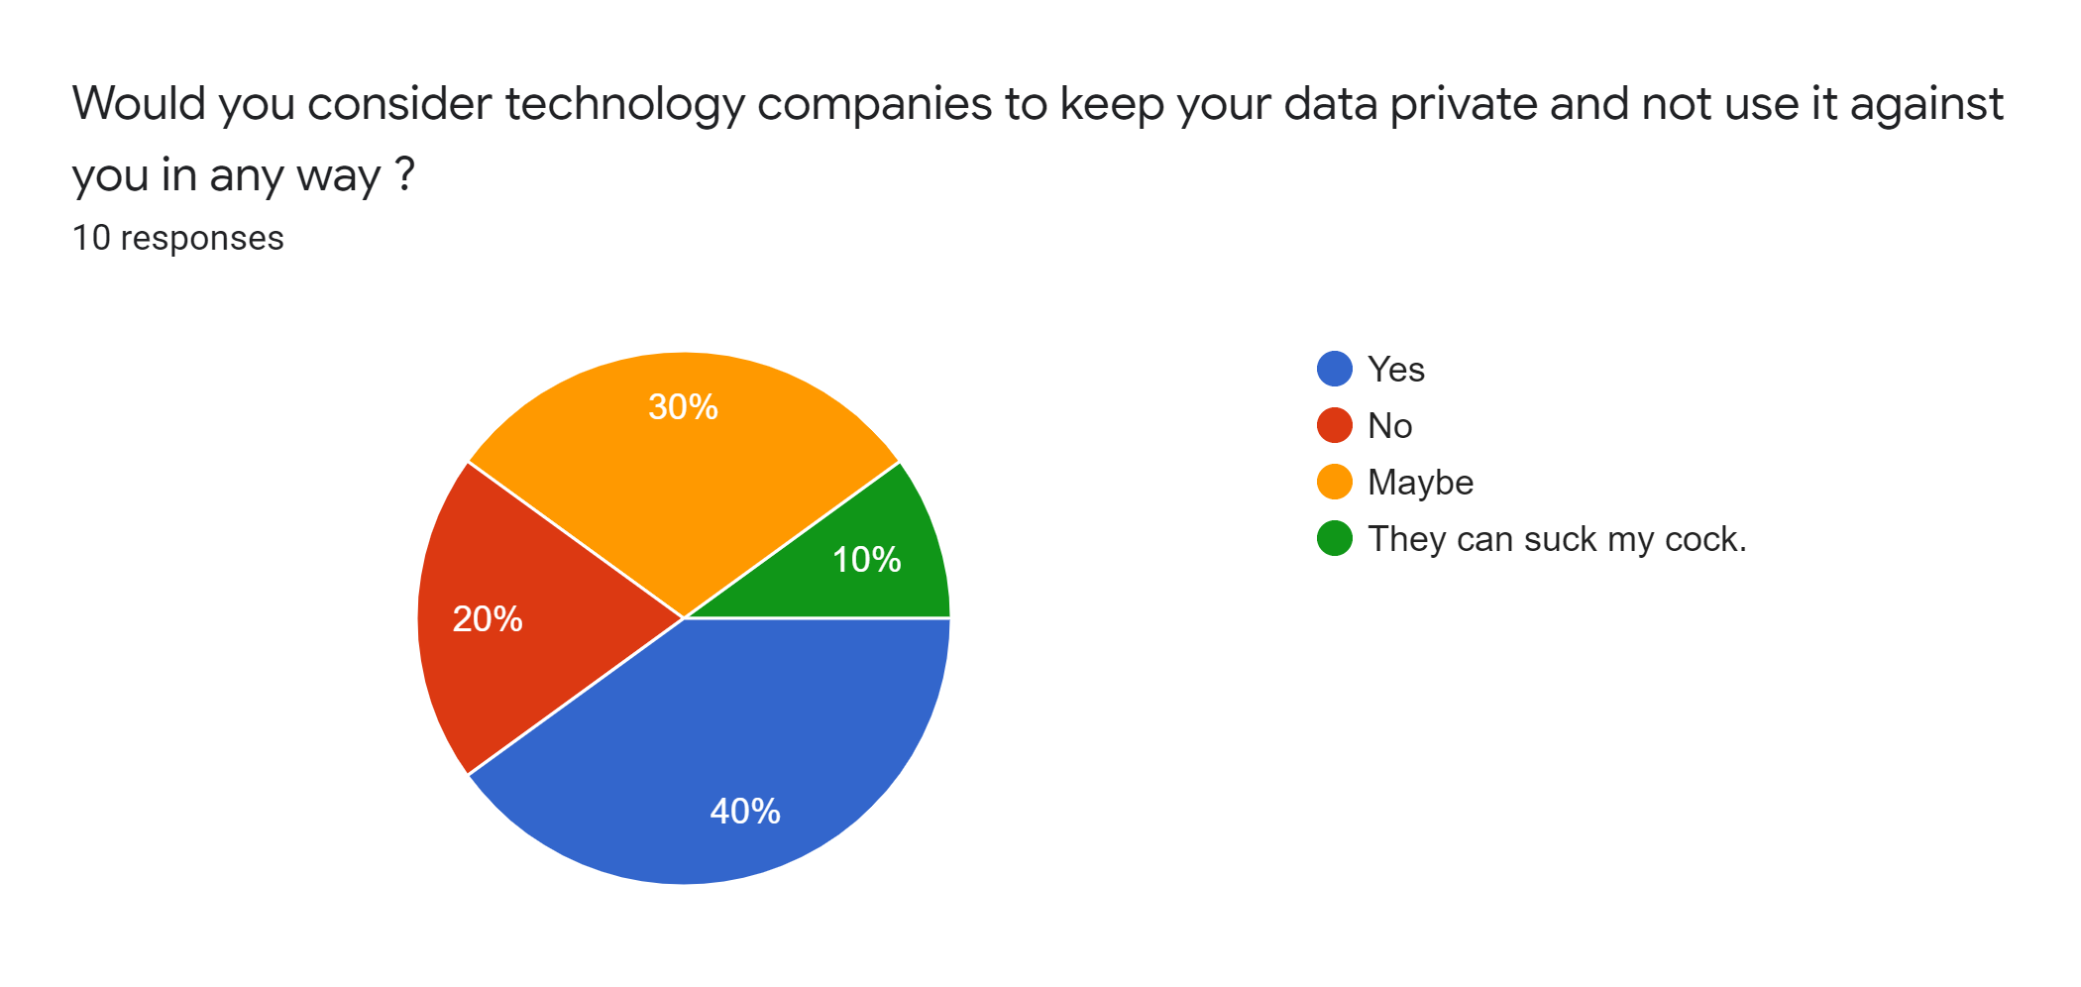

**Secondary research -**

The statistics below from the internet show the number of users in different age groups about if users trust social media companies with their personal information and not use it against them in any way for the year 2020.

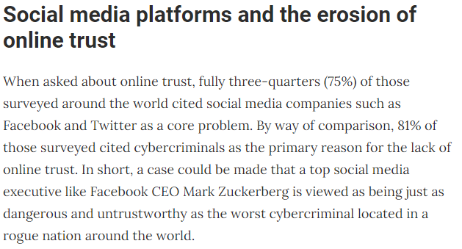

**Primary Research -**

The statistical graph shows the numbers of users from my local area about if users would change their perception of social media companies to track what they have been doing online for the year 2020.

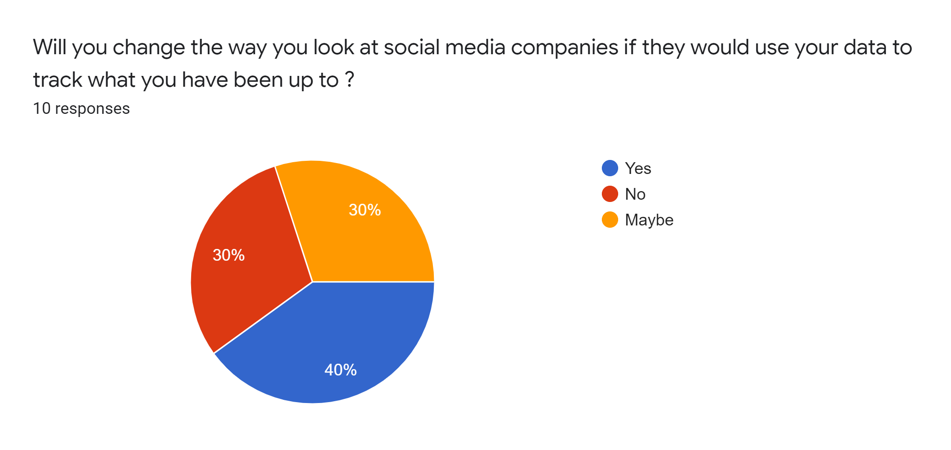

**Secondary research -**

The statistics below from the internet show the number of users in different age groups about if users would change their perception of social media companies to track what they have been doing online for the year 2020.

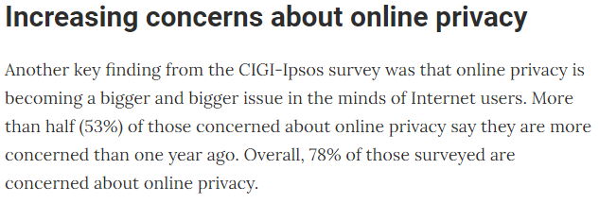

**Primary Research -**

The statistical graph shows the numbers of users from my local area about if users would change their perception of social media companies to track what they have been doing online for the year 2020.

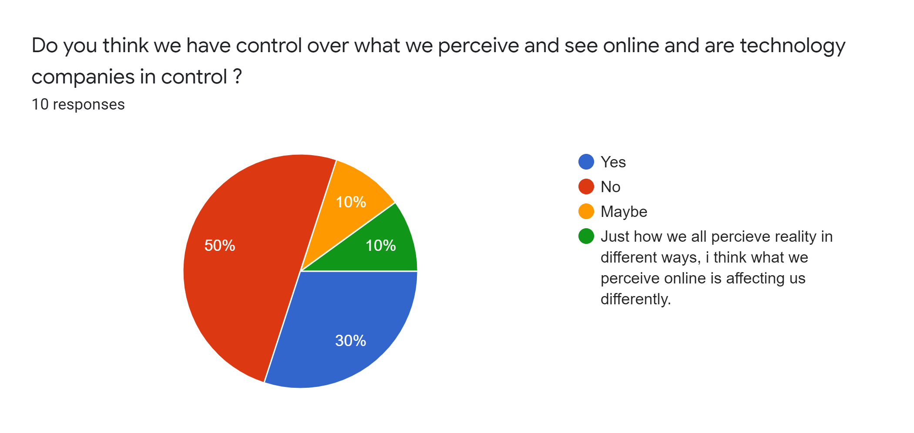

**Secondary research -**

The statistics below from the internet show the number of users in different age groups about if users would change their perception of social media companies to track what they have been doing online for the year 2020.

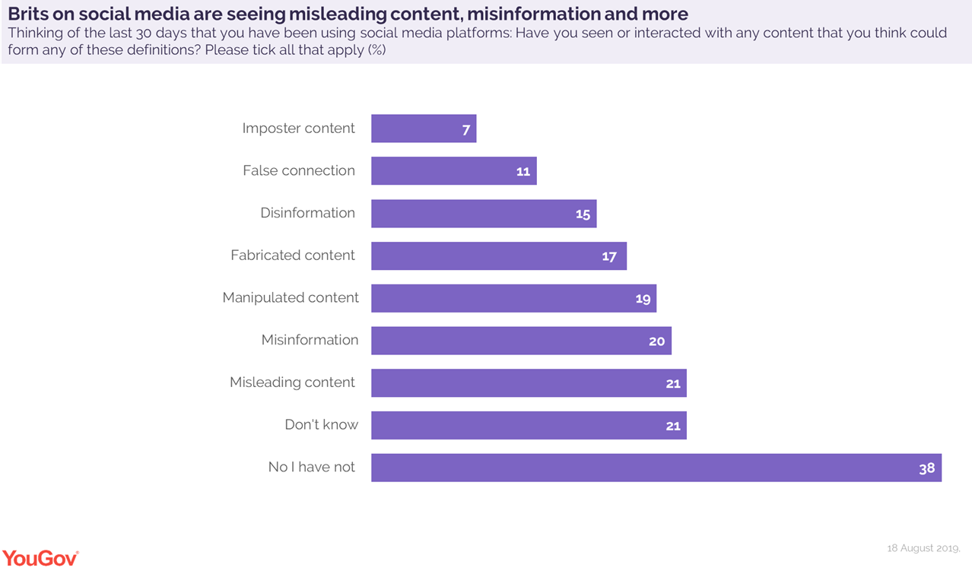

**Primary Research -**

The statistical graph shows the numbers of users from my local area about if users think technology companies responsible for health, safety and wellbeing for their users for the year 2020.

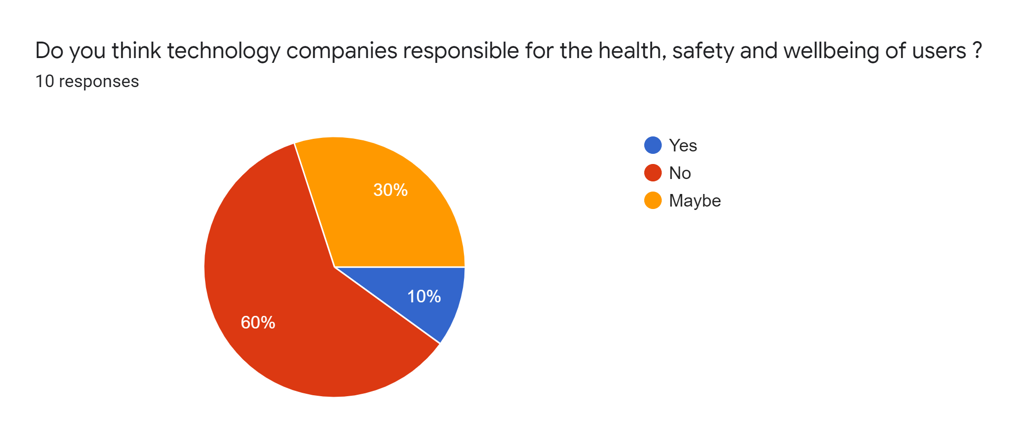

**Secondary research -**

The statistics below from the internet show the number of users in different age groups about if users think technology companies responsible for health, safety and wellbeing for their users for the year 2020.

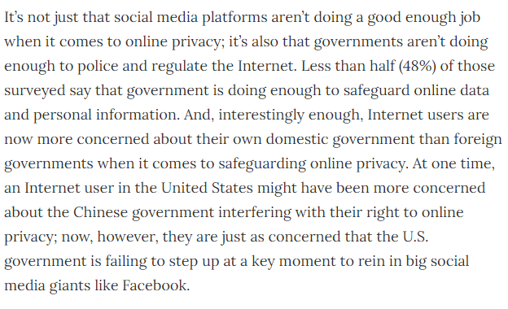

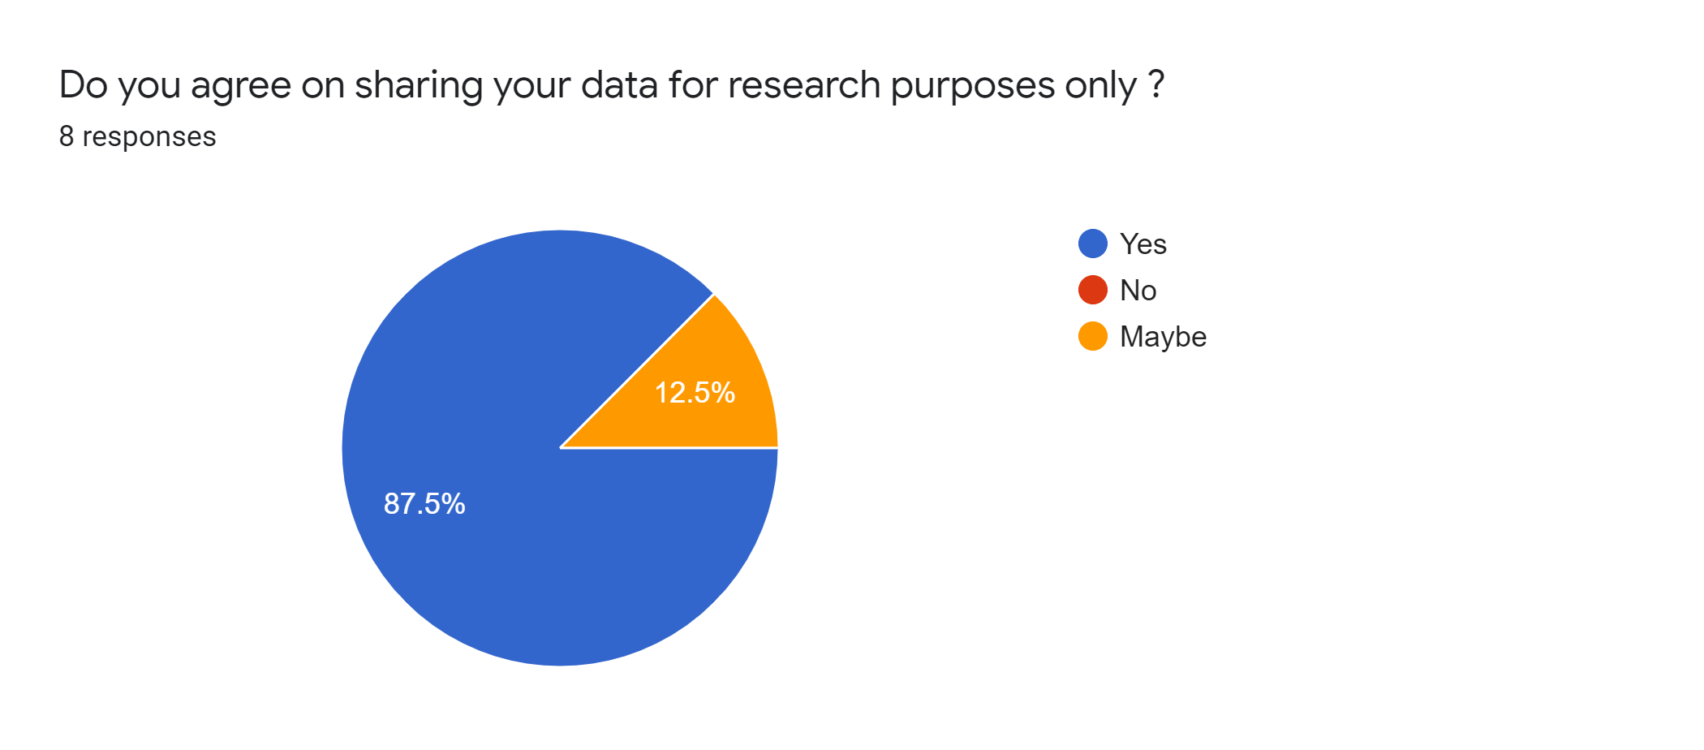

**Resources -**

Ons.gov.uk. 2020. *Young People Spend A Third Of Their Leisure Time On Devices - Office For National Statistics*. [online] Available at: <https://www.ons.gov.uk/peoplepopulationandcommunity/leisureandtourism/articles/youngpeoplespendathirdoftheirleisuretimeondevices/2017-12-19> [Accessed 20 March 2020].

Statista. 2020. *U.S. Internet Reach By Age Group 2019 | Statista*. [online] Available at: <https://www.statista.com/statistics/266587/percentage-of-internet-users-by-age-groups-in-the-us/> [Accessed 20 March 2020].

Statista. 2020. *Daily Internet Usage By Age And Device 2019 | Statista*. [online] Available at: <https://www.statista.com/statistics/416850/average-duration-of-internet-use-age-device/> [Accessed 20 March 2020].

Tech Jobs. 2020. *29+ Smartphone Usage Statistics: Around The World In 2020*. [online] Available at: <https://leftronic.com/smartphone-usage-statistics/> [Accessed 20 March 2020].

Limited, T., 2020. *Mobile Phone Usage Statistics In The UK: How Many Smartphone Users Are There - Tigermobiles.Com*. [online] TigerMobiles.com. Available at: <https://www.tigermobiles.com/blog/mobile-phone-usage-statistics/> [Accessed 20 March 2020].

Deloitte Insights. 2020. *To Share Or Not To Share*. [online] Available at: <https://www2.deloitte.com/us/en/insights/industry/retail-distribution/sharing-personal-information-consumer-privacy-concerns.html> [Accessed 20 March 2020].

BBC News. 2020. *'Only One In Four' Trust Social Media*. [online] Available at: <https://www.bbc.co.uk/news/business-42771740> [Accessed 20 March 2020].

eMarketer. 2020. *Trust Social Networks With Your Data? Nah. Use Social Anyway? Yep.*. [online] Available at: <https://www.emarketer.com/content/users-have-little-faith-in-social-networks-privacy-protections> [Accessed 20 March 2020].

Yougov.co.uk. 2020. *Social Media Content Is Often Unreliable, Say Users | Yougov*. [online] Available at: <https://yougov.co.uk/topics/technology/articles-reports/2019/10/31/social-media-content-often-unreliable-say-users> [Accessed 20 March 2020].

Lindsey, N., 2020. *Should Social Media Platforms Be Doing More To Win Back Online Trust?*. [online] CPO Magazine. Available at: <https://www.cpomagazine.com/data-privacy/should-social-media-platforms-be-doing-more-to-win-back-online-trust/> [Accessed 20 March 2020].

DigitalWellbeing.org. 2020. *Digital Wellbeing Statistics From Humane Tech Event*. [online] Available at: <https://digitalwellbeing.org/digital-wellbeing-statistics-from-humane-tech-event/> [Accessed 21 March 2020].